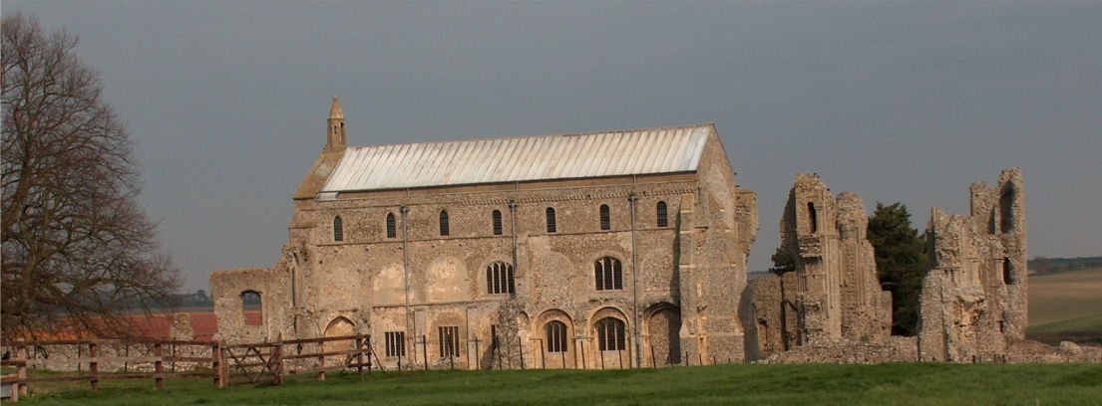
BINHAM PARISH COUNCIL
Locum Parish Clerk – Sarah Hayden
53 Cromer Road, Lower Gresham
NR11 8RH
Tel: 01263 570223
Email: sarah352hayden@btinternet.com

Parish Council Annual Meeting
Members of the Council
You are summoned to attend the annual meeting of Binham Parish Council via Zoom on
Thursday 6th May 2021 at 7.30pm
S. H. Hayden
Clerk
21st April 2021
The Public are welcome to attend this Parish Council meeting
Please contact the Locum Clerk for a link if you wish to attend
All documents requiring signature will be signed following this meeting

AGENDA

1. To elect a Chairman of the Council – signing of Acceptance of Office after meeting
2. To elect a Vice Chairman
3. To receive and accept apologies for absence
4. To Receive Declarations of Interest
5. Approval of the Minutes of Parish Council Meeting held 8th March 2021
6. Matters Arising from those Minutes

7. Reports
7.1 Norfolk County Council
7.2 North Norfolk District Council
7.3 Chair’s Report re: SAMS
7.4 Chair’s Report including any ongoing Covid 19 “Stay Secure” provisions

8. Planning
8.1 Report from Planning Committee
8.2 To discuss and make observations on any applications received after the date of this Agenda

9. Finance and Regulatory
9.1 To receive list of actuals against budget, balance sheet, bank reconciliation and explanation of variances to 31.3.20
9.2 To consider and approve the Annual Governance and Accountability Return as follows:
To complete the Certificate of Exemption
To receive the Annual Internal Audit Report 2019-20
To approve section 1 Annual Governance Statement
To approve section 2 Accounting Statements
9.3 To approve list of payments
9.4 To review all policies and risk assessments for Binham Parish Council.
9.5 To review the Parish Council’s insurance policy and approve payment of premium
9.6 To approve Clerk’s Contract of Employment

10. Update on draft flood plan for village
11. Items for Information Only or next Agenda
12. To fix the times and dates for ordinary meetings of the Council for the ensuing year

