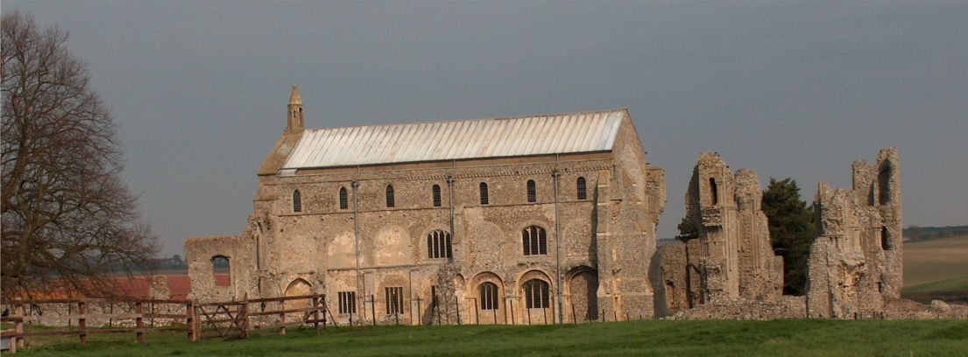
BINHAM PARISH COUNCIL
Parish Clerk – Sarah Hayden
53 Cromer Road, Lower Gresham
NR11 8RH
Tel: 01263 570223
Email: sarah352hayden@btinternet.com

2021/5
MINUTES OF THE PARISH COUNCIL MEETING HELD ON
MONDAY 8th March 2021 VIA ZOOM

Those Present Cllr. Liz Brady (Chair), Cllr. L. Brown (Vice Chair), Cllr. K. Cooke, Cllr. J. Hill, Cllr. L. Wynder
In Attendance Mrs. S. Hayden (Locum Clerk)
County Councillor Dr. M. Strong
District Cllr. Richard Kershaw (NNDC)
1 Member of the Public

The Chair opened the meeting at 7.30pm, stating that there would be no breaks as she now had a private subscription to Zoom
All documents/cheques to be signed by the Chair or Clerk will be signed following the meeting

1. Apologies received
None
2. To receive declarations of interest
None
3. Approval of Minutes of Parish Council Meeting held on 11th January 2021
The minutes were approved and would be signed by the Chair following the meeting
4. Matters Arising
None

5. Reports
5.1 Norfolk County Council
County Cllr. Dr. Strong has previously circulated her report, and added that she would send Census information. County Council Elections would be going ahead and postal voting makes sense under the restrictions. There was a planned phased opening of libraries. Apprentice schemes were ongoing and information for mental health and for bereaved families was contained in her report. [annexed to these Minutes]
5.2 North Norfolk District Council
District Councillor Kershaw reported that in connection with apprentices, there were currently 120 in North Norfolk – 8 at the Council and 112 with businesses in the district. The numbers would hopefully be up to 150 shortly. He had just attended a Covid meeting and there were 13 cases in N. Norfolk, the lowest in the country. Vaccinations in N. Norfolk were at the highest rate in the East of England. There had been a temporary shortage of vaccines, but they were coming in now. The message was still “keep trying to book”. The concentration was now on 2nd doses. There was new Government grant funding for recovery projects, which would not be available to parish or district councils, but for community projects. The Census Day would be on 26th March and postal votes were available.

The Chair said the low numbers of Covid19 cases was fantastic news and a recognition of all the hard work by all concerned, with vaccination delivery second to none. Cllr. Kershaw replied that NNDC had worked with CCG and the Council’s officers had been great – it was down to them. Cllr. Strong said that NNDC and the councillors had taken on much of the work during the pandemic.

2021/6
5.3 Chair’s Report re: SAMS
The Chair had previously circulated her report which is annexed to these minutes and which she summarised to the meeting. The SAM2 was now functioning correctly and had been started at Langham Road and was now at Warham Road. Langham Road traffic was down by half, due maybe to the snow and lockdown. The average speed is down and well below the speed limit. 2-14% are speeding, but the average is not far from the 30mph limit. Cllr. Wynder had noticed it was not working at the time she passed it. It would now be moved to Hindringham Road. It was moved every month and the battery changed. It should be serviced annually so that the data is accurate and this should be added into the Budget. The Clerk reported that Police would be carrying out speed checks in Hindringham shortly. She had reported the Hindringham Road data showing the highest speeds at the recent SNAP meeting.
5.4 Chair’s Report including any ongoing Covid 19 “Stay Secure” Provisions
The Chair reported that the Government’s advice was clear and an updated letter had been sent to every resident in the village, it was on the noticeboards and the Village Hall website. Cllr. Kershaw told the meeting that 57 Police Covid Notices had been issued in the previous week, NNDC had closed Cart Gap and Sea Palling car parks, but people still visited and just parked on the approach roads. Visitors came from Hull, Leicester, Northants. The Council would be putting out new decals and taking on more people as wardens. Second home owners breaching regulations, holiday lets after restrictions are lifted, difficulties with visitors and the level of fines for breaching regulations were all discussed.

6. Planning
6.1 Report from Planning Committee
The Chair of the Planning Committee was not in attendance, therefore the Clerk reported the following.

Applications decided since the last meeting were:
PF/20/1971 and PF/20/1970 External and internal alterations to original Grade II listed house, its north wing and north and west extensions, including reconfiguration of layout, re-roofing and upgrading of thermal performance of north and west extensions, demolition of existing conservatory and the addition of a garden room extension – The Pottery House, 41 Front Street, Binham NR21 0AL – Approved

PF/20/1911 Dormer extension to rear – 5 Front Street, Binham - Approved

Pending Applications
PF/20/1954 Single storey detached dwelling with accommodation within part of roof space – Land west of 49 Priory Crescent, Binham – Pending a decision

PF/20/2562 Mallards, Langham Road, Binham – Extension of garage roof and installation of PV panels; replacement fence to front boundary (part retrospective) – Pending a decision

Cllr. Kershaw reported that in connection with PF/20/1954 he noted that the Parish Council had not objected. The Planning Department were minded to refuse the application and he had been in touch with the applicant to update him. He had asked the planning officer to consider calling the application in, but that had not been done yet. The Chair reported that there was lots of activity in the village with work to trees and pollarding.
6.2 To discuss and make observations on any applications received after the date of this Agenda
None
6.3 To comment of NNDC Community Governance Review
The Clerk outlined the proposed changes to the parish boundary, which meant that a property between Binham and Hindringham would be moved within the Hindringham boundary rather than be split in two. Approved.

On other planning matters, the Chair invited a member of the public to speak on the changes at the Church. He reported that the east door on the south side that had been blocked since the 19th century is now being opened, so that the connection between the nave and Monk’s Church will be reinstated. The work should start in two weeks’ time. Internally the alter rails would be moved to form a square and passage to the door. The door would be self-closing with a lock operated from inside, as well as a latch. It would be open most of
2021/7

the time. English Heritage had supported the scheme and would be putting an information sign in place. It was hoped that the door may draw visitors into the Church rather than just the ruins. The work had been funded by a memorial donation.
Cllr. Hill raised a question on enforcements generally and was asked for a list of those he considered a problem. The Clerk would forward a copy of the enforcement officer’s email in connection of a closed case.

Cllr. Kershaw made his apologies and left the meeting

7. Maintenance
7.1 To discuss and approve provision of dog waste bin/s
The Chair reported that the bin she favoured cost £120 plus VAT. This was approved.
7.2 To discuss emptying of bus shelter bin
The Chair explained that currently Cllr. Brown kindly emptied the bin and asked if the Parish Council would consider a new bin and emptying by NNDC. Cllr. Brown was happy to continue, but it was agreed to get costs for the next meeting. Other maintenance was discussed.

8. Finance and Regulatory
8.1 To approve List of Payments
The List of Payments was approved and signed by the Clerk
8.2 To receive budget with actuals, balance sheet and report on bank reconciliation
There were no matters raised on the budget and balance sheet. The bank reconciliation had been sent that day and Cllr. Brown had not been able to check it, for which the Clerk apologised. However, it would shortly be checked as an end of year matter going to the internal auditor and be approved at the next meeting.
8.3 To approve Contract of Employment for Clerk
The Contract had not been completed, but it was proposed and resolved that the Clerk be asked to accept the permanent position of Clerk. She thanked the Parish Council and accepted.
8.4 To appoint auditor for the 2020-21 accounts
The previous auditor, Mike Gates had been asked if he would be willing to audit the accounts and he had accepted. Proposed that he be appointed. Resolved.

9. Update on draft flood plan for village
The Chair and Cllr. Alford had been collating photos and videoing at drains/flood areas. They had spoken to people in the village who were quite keen to focus on managing the drains, and they had had discussions with farmer in the area. The Stiffkey road had been clogging up badly, but that was now cleared, as had the manholes on the Langham corner. Cllr. Hill reported that a lot of water was missing gullies. There were still gullies on Stiffkey Road that were blocked. The Chair would continue work on a draft with the evidence gathered.

11. Items for Information Only or Next Agenda
1. The missing sign at Cockthorpe had been reported.
2. Funds were available through the Sustainable Communities Fund that may benefit the Village Hall and Youth Group
3. C & S Hudson had kindly agreed to continue cutting the grass at the same rates as last year.
4. It was noted that grant funding had been awarded for the Dairy Shop, so work would commence.
5. “Brighten up Binham” had successfully had 20 tubs made and painted ready for planting, with wood being donated. The Parish Council would take responsibility for them when planted.
Next Agenda: Parking at Priory Crescent and the possibility of construction of a layby

The Parish Annual Meeting was discussed in connection with Covid restrictions. The date would be agreed as stages through restrictions progressed.

The meeting closed at 9pm
The Parish Council Annual Meeting would be on 10th May 2021

