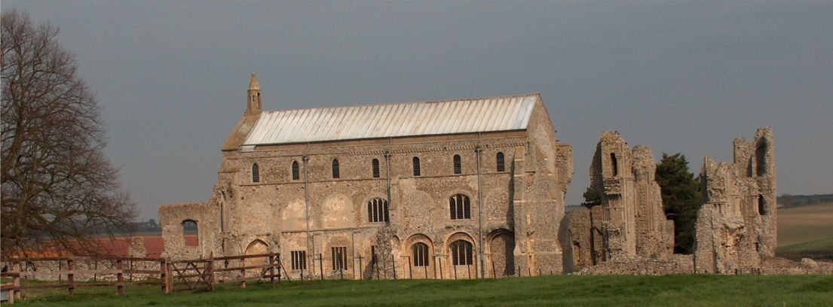
BINHAM PARISH COUNCIL
Locum Parish Clerk – Sarah Hayden
53 Cromer Road, Lower Gresham
NR11 8RH
Tel: 01263 570223
Email: sarah352hayden@btinternet.com

Parish Council Meeting
Members of the Council
You are summoned to attend a meeting of Binham Parish Council via Zoom on
Monday 8th March 2021 at 7.30pm
S. H. Hayden
Locum Clerk
2nd March 2021
The Public are welcome to attend this Parish Council meeting
Please contact the Locum Clerk for a link if you wish to attend
All document requiring signature will be signed following this meeting

AGENDA

1. To receive and accept apologies for absence

2. To Receive Declarations of Interest

3. Approval of the Minutes of Parish Council Meeting held 11th January 2021

4. Matters Arising

5. Reports
5.1 Norfolk County Council
5.2 North Norfolk District Council
5.3 Chair’s Report re: SAMS
5.4 Chair’s Report including any ongoing Covid 19 “Stay Secure” provisions

6. Planning
6.1 Report from Planning Committee
6.2 To discuss and make observations on any applications received after the date of this Agenda
6.3 To comment on NNDC Community Governance Review

7. Maintenance
7.1 Update on provision of dog waste bin
7.2 To discuss emptying of bus shelter bin

8. Finance and Regulatory
8.1 To approve List of Payments.
8.2 To receive Budget with Actuals, balance sheet and report on Bank Reconciliation
8.3 To approve Contract of Employment for Clerk
8.4 To appoint auditor for 2020-21 accounts

9. Update on draft flood plan for village

10. Items for Information Only or next Agenda

The next meeting will be on 10th May 2021 preceded by the Annual Parish Meeting

