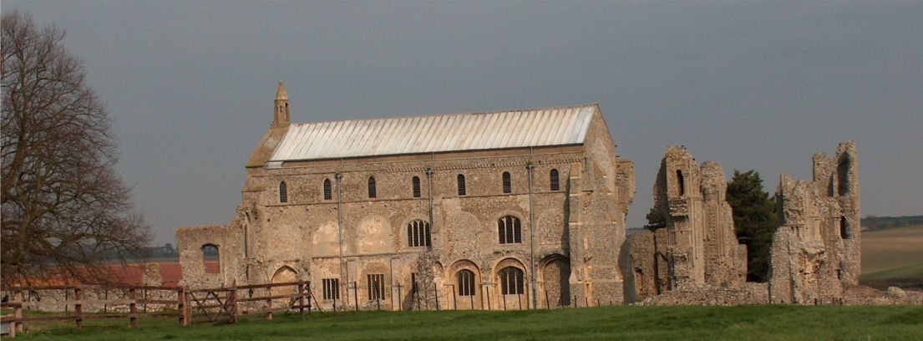
BINHAM PARISH COUNCIL
Locum Parish Clerk – Sarah Hayden
53 Cromer Road, Lower Gresham
NR11 8RH
Tel: 01263 570223
Email: sarah352hayden@btinternet.com

2021/1
MINUTES OF THE PARISH COUNCIL MEETING HELD ON
MONDAY 11th January 2020 VIA ZOOM

Those Present Cllr. Liz Brady (Chair), Cllr. L. Brown (Vice Chair) Cllr. P. Alford, Cllr. K. Cooke, Cllr. J. Hill, Cllr. L. Wynder
In Attendance Mrs. S. Hayden (Locum Clerk)
County Councillor Dr. M. Strong
District Cllr. Richard Kershaw (NNDC),
2 Members of the Public

The Chair opened the meeting at 7.32pm, thanked all for attending and explained the procedure for this meeting via Zoom.

1. Apologies received
Apologies were received and accepted from Cllr. H .Owen (working)

2. To receive declarations of interest
Cllr. L. Wynder declared an interest in item 6.1 planning application PF/20/2562 and would not speak or vote on the matter

3. Approval of Minutes of Parish Council Meeting held on 9th November 2020
Amendments previously circulated by the Chair were approved and the Minutes were then signed by the Chairman. Amendments were to item 5.3 first line “signs” replaced by “SAM”, third line “sign” replaced by “SAM”, fifth line “signs are” replaced by “SAM is”

4. Matters Arising including (but not limited to): Binham Tributary ecology rating; parish pit; Fakenham proposed housing and its effect on surrounding highways.
Binham Tributary – the Clerk had tried to find the report on the Environment Agency website, but was unable to do so.
Parish Pit – Cllr. Alford and the Clerk proposed to check the Parish Council’s deeds and documents which held at the Norfolk Records Office, when Covid restrictions allowed.
Fakenham - As Cllr. Strong had not yet joined the meeting, Cllr. Kershaw who was on the Development Committee informed the meeting that the housing application had been approved, although the highways details were yet to be considered and agreed, with several comments having been received.

5. Reports
5.1 Norfolk County Council
As County Cllr. Strong has not yet jointed the meeting, Cllr. Kershaw gave his report first.

5.2 North Norfolk District Council
District Councillor Kershaw reported that there would shortly be a Census, with a postcard being sent out with instructions for completing this on-line or paper. It would be the last Census carried out as there was not the political will to do so and the results were time consuming and expensive to produce. 21st March was census day. In connection with Kickstart, that was going well with 120 16 to 24 years olds on six month
2021/2

courses. The tree planting target was also going well with 20,000 trees planted although there was a need for more land. Cllr. Kershaw had recently attending a meeting with Norfolk County Council and the Covid 19 numbers were slightly reducing in most regions. In N. Norfolk 169 warning and 69 tickets had been issued with increased numbers holidaying or visiting the area. There were now eight wardens touring car parks. A campaign aimed at supermarkets had been instigated, with enforcement officers advising on compliance with restrictions, as some had relaxed their rules. Track and Trace analysis had shown households were responsible for spreading the virus. Care Homes were experiencing lower numbers, as were food processors. Eleven inoculation centres started vaccinating this week, but the message was for people to wait for NHS/surgeries to get in touch with them for appointments.

Planning was discussed and Cllr. Kershaw offered his help.
A member of the public offered his thanks to the Parish Council for their comments on his application, which he felt would help.

Norfolk County Council
County Councillor Dr. Marie Strong reported that school meals were available for those entitled and the Norfolk Assistance Scheme was there to help for those who needed it. If anyone was known who could benefit they should be encouraged to claim. She felt that as Flood Co-ordinator for Wells, it would be a good idea for the Parish Council to go ahead with a flood plan for the village.

Cllrs. Strong and Kershaw made their apologies and left the meeting.

5.3 Chair’s Report re: SAMS
The chair had previously circulated her report which is annexed to these minutes and which she summarised to the meeting. She added that recalibration of the SAM2 could be done annually which would be worthwhile and should be budgeted for in the future.

5.4 Chair’s Report including any ongoing Covid 19 “Stay Secure” Provisions
This report was included in the above. The Chair explained that as regulations were changing so quickly she felt it was better to put the newsletters on the noticeboards and website, rather than delivering to every household and the news becoming out of date quickly. Again, she summarised her report to the meeting.

Agreement with all parties had been reached on the provision of the dog waste bin at the Priory. English Heritage had been asked if they could contribute towards the costs and a reply was awaited. It would be coloured green and situated on a fence post to the left of the entry to the Priory ruins.

The meeting adjourned at Zoom 40 time limit and re-convened when reconnected. All parish councillors in attendance during the first part of the meeting re-joined, except Cllr. Wynder and Cllr. Hill who re-joined at item 7
Cllrs. Strong and Kershaw, plus one member of the public left the meeting.

6. Planning
6.1 Report from Planning Committee
Cllr. Alford reported that:
Her report had previously been circulated to the parish councillors.
There had been one new application since the last meeting
There had been two applications decided since the last meeting
There were two pending since the last meeting, two of which were Pottery House.

New applications:
PF/20/2562 Mallards, Langham Road, Binham – Extension of garage roof and installation of PV panels; replacement fence to front boundary (part retrospective). This had not been received by the Parish Council as usual and was only noted on the planning portal today, 11.1.20. Therefore the planning committee would look at the application and deal with it as per the planning protocol.

2021/3

Tree works were reported on in the area. The Parish Council is not a consultee on these and details are available on the NNDC website.

Applications decided since the last meeting were:

LA/20/1125, PF/20/1077 – The Barn at Abbey Farm – conversion to a café - Approved 8th November 2020

Pending Applications:
PF/20/1971 and PF/20/1970 External and internal alterations to original Grade II listed house, its north wing and north and west extensions, including reconfiguration of layout, re-roofing and upgrading of thermal performance of north and west extensions, demolition of existing conservatory and the addition of a garden room extension – The Pottery House, 41 Front Street, Binham NR21 0AL – Cllr. Alford confirmed that Binham Parish Council had supported this application and a decision was still pending.

PF/20/1954 Single storey detached dwelling with accommodation within part of roof space – Land west of 49 Priory Crescent, Binham – The Parish Council had supported this application. It was noted that the Design and Conservation Officer comment was “still does not appeal from a conservation and design perspective. Equally however, it is acknowledged that the heritage grounds for refusal are nowhere near as strong as they were previously” (a previous application had been withdrawn). Pending a decision

PF/20/1911 Dormer extension to rear – 5 Front Street, Binham – The Parish Council had supported the decision. The Conservation & Design Officer comment was “Although it has to be acknowledged that the scheme is unlikely to result in harm to either the conservation area or the adjacent listed building, C & D consider that the inappropriate scale and design are contrary to local policy EN4 and as such are reluctant to offer support to the application”. Pending a decision.

6.2 To discuss and make observations on any applications received after the date of this Agenda
None, other than as 6.1

7. Maintenance
7.1 To discuss and approve provision of dog waste bin/s
An update on this had been dealt with in the Chair’s report item 5.4
7.2 To discuss and approve provision of waste bin at the cemetery
An update on this had been dealt with in the Chair’s report item 5.4. The PCC had been approached for a contribution to the costs. No further action would be taken for the time being.
7.3 To discuss and approve maintenance work in village following asset check
The budget was very tight, and it was proposed and agreed to use the balance of the donations budget for the unexpected repair/service of the SAM2 at £204. Maintenance of the benches and fence at the allotments was discussed and for the present, it was proposed and agreed to refurbish the lower Green bench only. The clerk was asked to check with the Stody Estate whose responsibility the fence was. Cllr. Alford as a member of the BInham Local History Group had felt the village sign was an important part of the village and had asked if they would be prepared to make a donation for the repairs, to which they had agreed. The Chair thanked her on behalf of the Group. The repair and painting of the sign by the original carver had been arranged by Cllr. Owen who was also thanked for her efforts. The bus shelter bin emptying was briefly discussed as it was felt that a regular service should be paid for. This would be dealt with at the next meeting.

8. Finance and Regulatory
8.1 To receive Balance Sheet and approve List of Payments
The Balance Sheet was received. The List of Payments was approved

2021/4

8.2 To approve Standing Orders, Financial Regulations and other policies currently drafts on website
Standing Orders had been approved at the November meeting. Proposed and resolved to approve all Financial Regulations and all other policies as on website.
8.3 To appoint councillor to check bank reconciliations
It was proposed and resolved to appoint Cllr. L. Brown to check reconciliations

9. Update on proposed application for Green footpaths to the Definitive Map
Cllr. Alford stated that Norfolk County Council had outlined the method of an application, by collecting statements from users of the paths. However, Cllr. Alford and the Clerk would attend the Norfolk Records Office as soon as restrictions allowed to check Parish Council deeds and documents in case they owned the paths. If not, there could be approaches to property owners adjacent to see if they owned the paths, before proceeding to collect any statements. Agreed this was the best route.

10. To discuss formulating flood plan for village
It was felt that any flooding was surface water flooding caused by blocked drains, although a lot of recent work had been carried out by Highways. The resolution to this was for the parish councillors to keep an eye on the road drains and report promptly to Highways if they appeared blocked. However, the Chair would look at preparing a draft of a flood plan and the Clerk offered to assist.

11. Items for Information Only or Next Agenda
As item 7.3 – bus shelter bin emptying

There being no further time on Zoom and no further business the meeting closed at 8.43pm

The next meeting will be on 8th March 2021

