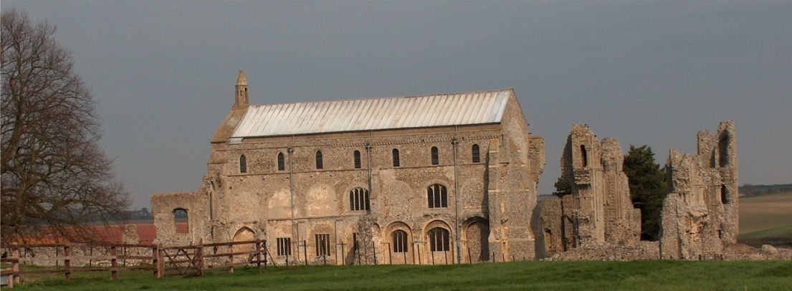
BINHAM PARISH COUNCIL
Locum Parish Clerk – Sarah Hayden
53 Cromer Road, Lower Gresham
NR11 8RH
Tel: 01263 570223
Email: sarah352hayden@btinternet.com

Parish Council Meeting
Members of the Council
You are summoned to attend a meeting of Binham Parish Council via Zoom on
Monday 11th January 2021 at 7.30pm
S. H. Hayden
Locum Clerk
4th January 2021
The Public are welcome to attend this Parish Council meeting
Please contact the Locum Clerk for a link if you wish to attend

AGENDA

1. To receive and accept apologies for absence

2. To Receive Declarations of Interest

3. Approval of the Minutes of Parish Council Meeting held 9th November 2020

4. Matters Arising including (but not limited to): Binham Tributory ecology rating; parish pit; Fakenham proposed housing and its effect on surrounding highways.

5. Reports
5.1 Norfolk County Council
5.2 North Norfolk District Council
5.3 Chair’s Report re: SAMS
5.4 Chair’s Report including any ongoing Covid 19 “Stay Secure” provisions

6. Planning
6.1 Report from Planning Committee
6.2 To discuss and make observations on any applications received after the date of this Agenda

7. Maintenance
7.1 Update on provision of dog waste bin
7.2 To discuss and approve provision of waste bin at cemetery
7.3 To discuss and approve costs of maintenance work in village

8. Finance and Regulatory
8.1 To receive balance sheet and approve List of Payments, including repairs/service to SAM2 sign
8.2 To approve Standing Orders, Financial Regulations and other policies currently drafts on Parish Council website https://binhampc.norfolkparishes.gov.uk
8.3 To appoint councillor to check bank reconciliations

9. Update on proposed application for Green footpaths to the Definitive Map

10. To discuss formulating flood plan for village

11. Items for Information Only or next Agenda

The next meeting will be on 8th March 2021

