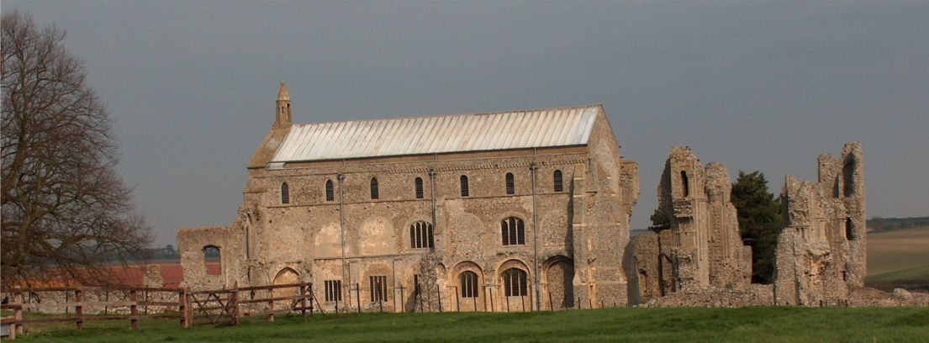
BINHAM PARISH COUNCIL
Locum Parish Clerk – Sarah Hayden
53 Cromer Road, Lower Gresham
NR11 8RH
Tel: 01263 570223
Email: sarah352hayden@btinternet.com

2020/13
MINUTES OF THE PARISH COUNCIL MEETING HELD ON
MONDAY 9th November 2020 VIA ZOOM

Those Present Cllr. Liz Brady (Chair), Cllr. P. Alford, Cllr. K. Cooke, Cllr. J. Hill, Cllr. H. Owen, Cllr. L. Wynder
In Attendance Mrs. S. Hayden (Locum Clerk)
County Councillor Dr. M. Strong
District Cllr. Richard Kershaw (NNDC),
3 Members of the Public

The Chair opened the meeting at 7.32pm, thanked all for attending and explained the procedure for this meeting via Zoom.

1. Apologies received
Apologies were received and accepted from Cllr. L. Brown

2. To receive declarations of interest
None

3. Approval of Minutes of Parish Council Meeting held on 14th September 2020
Approval proposed and resolved, and the Minutes were then signed by the Chairman

4. Matters Arising
A question was raised on public participation. This would be dealt with at item 9.4

5. Reports
5.1 Norfolk County Council
County Cllr. Dr. M. Strong’s regular reports had been previously circulated and are annexed to these minutes. She confirmed that all Covid 19 related updates were available on the NCC website, so she did not report them in her newsletters as they changed so quickly. Cllr. Alford asked if the Highways Authority would look at the impact of the new Cherry Tree roundabout on the Shell and Morrisons roundabouts as it was not unusual for tailbacks to occur already. Cllr. Strong replied that this was a complex process and needed to go to planning, but it could not go ahead if it defaults another position, so would be looked at carefully. She had noticed item 10 and offered help if required.
5.2 North Norfolk District Council
District Councillor Kershaw reported that there would be new software installed shortly on the NNDC planning portal, with no new applications being put on the current system, although we could still submit comments on existing applications. The Covid 19 emergency number was being reinstated (01263 516000) during working hours and the resilience centres may open again as there was funding available. Kickstart hub has worked for the first 30 applicants and the second 30 are now being progressed. NNDC are working with Shell at the Bacton site, who have helped with a six figure sum. NNDC are now also rolling out a third tier of grants and will publish the figures on their website. The Chair thanked Cllr. Kershaw for his help during the previous week, with a proposed planning application.

2020/14

5.3 Chair’s Report re: SAMS
There were five sets of data on the latest report, which included Cockthorpe, who had requested the signs as there was a perception of speeding, considered to be dangerous. The figures showed that the highest speeds were still at the Hindringham road gates, with none higher than that position. The bus shelter sign showed an alarming number of vehicles up until last week. There may be a problem in heavy rain as the signs are sensitive and may pick up rain as traffic. The increase in traffic could be caused by an increase in farm traffic with harvesting of maize, potatoes, sugar beet, as well as ploughing and drilling, so there could be 1,000 farm journeys per day. Hindringham Parish Council’s Speedwatch training is now on hold due to Covid 19 restrictions. The detailed SAM 2 data had been circulated to parish councillors.

5.4 Chair’s report including any ongoing Covid 19 “Stay Secure” provisions
Newsletters had been delivered last Friday to all residents. There are slight changes in restrictions every day and we still need to be vigilant. The Parish Council were working with the Memorial Hall Committee and PCC and were here to help.

6. Planning
6.1 Report from Planning Committee
Cllr. Alford had circulated the report before the meeting. There had been five new applications, with two for one address.
Applications decided since the last meeting were:
PF/19/2153 - Pebble Cottage, 87 Warham Road – two storey side and rear extension – Approved 6 Oct 20
LA/20/0740 - 1 Front Street - window change in character – Approved 30 Oct 20
Applications pending:
LA/20/1125, PF/20/1077 – The Barn at Abbey Farm – conversion to a café - there were two recent letter on NNDC website from Historic England (no objection if archaeological survey done) and the Countryside and Development Officer who was happy with the amendments to the plans. Cllr. Hill had seen the applicant very recently, who was expecting approval within a couple of days.
New Applications:
PF/20/1971 and PF/20/1970 External and internal alterations to original Grade II listed house, its north wing and north and west extensions, including reconfiguration of layout, re-roofing and upgrading of thermal performance of north and west extensions, demolition of existing conservatory and the addition of a garden room extension – The Pottery House, 41 Front Street, Binham NR21 0AL – Cllr. Aldford outlined the application and asked the Council to look at the plans in detail before commenting to her, as this would be a lot of work to a Grade II listed building. She felt it may help to meet the applicant if possible and mentioned previous applications.
PF/20/1954 Single storey detached dwelling with accommodation within part of roofspace – Land west of 49 Priory Crescent, Binham – Cllr. Alford reported that this could be viewed from the footpath and had been the subject of a previous pre-application and one application that the Parish Council had not supported. This was a new application for a single-story property with biggish roof (with living). She asked if councillors could look at the application and forward comments to her.
PF/20/1911 Dormer extension to rear – 5 Front Street, Binham – This was a dormer extension not visible from the road. There was no objection provided care was taken with contractor’s vehicles due to the position near the junction. Cllr. Hill mentioned that there may be an overlooking situation for the neighbour, but it was felt the neighbour had the opportunity to object if they wished direct to NNDC.
Pre-Application:
Manor Farm – exempted Camp Site for a maximum of 5 caravans/motorhomes and ten tents on behalf of the Caravan and Camping Club. Cllr Alford passed this to the Chair as she lived nearby and felt she had an interest and did not wish to speak on the pre-application. The Chair explained that this had been an ongoing matter, firstly to be situated on the Hindringham Road side of the village, then behind the barn on the Field Dalling Road and now Manor Farm Barns. District Cllr. Kershaw had visited the site with the Committee. The Caravan and Camping Club would not be taking the application any further for the time being. Cllr. Kershaw confirmed that it had been withdrawn.

2020/15

The Chair asked if a member of the public would like to comment on his application PF/20/1954. He confirmed that everything was on the Design & Access Statement and he will continue to improve the site. He wished to get on well with his neighbours and hoped the Parish Council were seeing the improvement. He then thanked the Chair for the opportunity to speak.
6.2 To discuss and make observations on any applications received after the date of this Agenda
None

7. To discuss and agree arrangements for Christmas in the village
The Chair would try to put something in the Lynx – all villages were doing something to try and bring cheer to their villages. Ideas included: a challenge to make a decoration for the tree which would be on the Green as usual; challenge to light up homes and decorate with advent wreaths. The “pumpkin challenge” had been well received. It was not yet known what Church services would be held, depending upon restrictions. There were plans for the Iceni choir in Christmas week and an Epiphany choir in January. This would be publicised when finalised.

District Cllr. Kershaw made his apologies and left the meeting

8. Maintenance
8.1 To discuss and approve provision of dog waste bin/s
The Chair outlined the reasons for supplying a dog waste bin and the two possible positions for a dog waste bin at the Priory. The PCC had been consulted as had the Dairy Farm landowners. It had been agreed that the bin would be green or black and would be placed on a pole to prevent damage to any wall. Two prices had been obtained from Glasdon and Kingfisher, with Kingfisher being lower. The approximate cost would be £150, with collections at £3.40 per collection (cost this financial year). The next stage would be to seek consent from Norfolk Archaeological Trust and English Heritage.

County Councillor Dr. M. Strong made her apologies and left the meeting

8.2 To discuss and approve provision of waste bin at the cemetery
It was felt that a general waste bin (140 litres) was need at the cemetery in addition to the garden waste bin. Agreed to purchase bin up to a cost of £50 from Kingfisher. The Chair would contact the PCC to ask if they would be prepared to contribute to the cost.
8.3 To discuss and approve maintenance work in village following asset check
Cllr. Owen had been in contact with the original sign maker in connection with refurbishing the village sign. He would visit and let us know if he could take it home to deal with. It was not known who owned the fencing at the allotments – Clerk to investigate. The preferred person to deal with the refurbishment of the benches did not have third party liability insurance – Clerk to contact our insurers to check the situation. Many signs in the village had rusting bases – Highways Authority would be asked to check them. Dairy Farm drain is still blocked despite Highways being informed and chased. Cllr. Alford had also chased.

9. Finance and Regulatory
9.1 To receive Balance Sheet and approve List of Payments
The Balance Sheet was received. The former clerk had offered his backdated pay increase as a donation to the Memorial Hall, which was accepted with thanks. The cheques had been signed prior to the meeting except the donation cheque.
9.2 To consider Budget, approve and set precept for 2021-22
The proposed Budget was thoroughly discussed, including the amount needed by the Parish Council and the percentage increase to council tax payers. It was proposed and resolved to set the precept at £6,200.
9.3 To consider donation to Youth Group to assist re-opening following Covid shutdown
The Chair had been in contact with the Group who did not wish to proceed with their necessary training for re-opening at the moment and would reconsider when the Covid restrictions were lifted and the proposals for re-opening the Group was more certain.

2020/16

9.4 To approve Standing Orders, Financial Regulations and other policies currently drafts on website
Standing Orders: The clause for a public participation session to be incIuded on the Agendas for meetings was discussed. The Clerk had taken advice and confirmed the Parish Council could continue its public participation as at present, by permission of the Chair. It was agreed not to include a separate session and continue as at present. Proposed and resolved to approve Standing Orders with this amendment. It was agreed to defer approval of other policies until the next meeting to allow more time for the parish councillors to read through them.

10. Update on proposed application for Green footpaths to the Definitive Map
Cllr. Alford had been looking at old maps and the Definitive Map to check whether any more rights of way needed to be included on the Definitive Map. The purchasers of the property next to one of the Green footpaths had asked what the position was, so they were aware of the current moves to register.

11. Items for Information Only or Next Agenda
1. Cllr. Owen asked if the Clerk had heard any further on the proposals by the NALC wellbeing committee to form a group of coastal parish councils – she had not.
2. The Clerk as if anyone had seen the report in the EDP that the Binham tributary to the River Stiffkey was rated as a “bad” ecology rating and read out the possible causes. It was agreed this was worth further enquiry.
3. The new Cherry Tree roundabout was discussed and Cllr. Alford agreed to draw up some draft comments to be submitted when a consultation was carried out.
4. Cllr. Hill asked where and what was the “Parish Pit” was (Binham to Langham road). The Clerk explained that these were surveyors pits from the days when materials were left there. The Parish Council was entitled to the rents from these pits, but did not own them. Clerk agreed to circulate a leaflet she had from NNDC about these pits. This to be an Agenda item for the next meeting.

There being no further business the meeting was closed at 9.40pm
The next meeting will be on 11th January 2021

