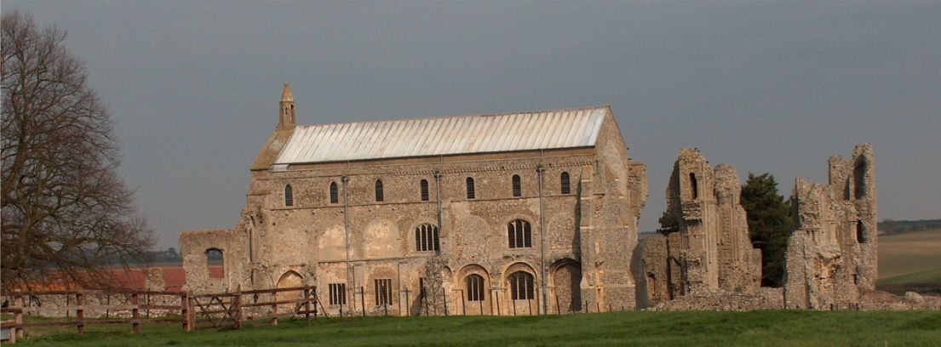
BINHAM PARISH COUNCIL
Locum Parish Clerk – Sarah Hayden
53 Cromer Road, Lower Gresham
NR11 8RH
Tel: 01263 570223
Email: sarah352hayden@btinternet.com

Parish Council Meeting
Members of the Council
You are summoned to attend a meeting of Binham Parish Council at The Memorial Hall on
Monday 9th November 2020 at 7.30pm
S. H. Hayden
Locum Clerk
31st October 2020
The Public are welcome to attend this Parish Council meeting
Covid 19 precautions will be in place
Please bring a mask and use hand sanitiser at door on way in and out
You will be asked to leave your name and telephone number to assist “Track & Trace” – these details to be kept for 21 days and then destroyed

AGENDA
1. To receive and accept apologies for absence
2. To Receive Declarations of Interest
3. Approval of the Minutes of Parish Council Meeting held 14th September 2020
4. Matters Arising

5. Reports
5.1 Norfolk County Council
5.2 North Norfolk District Council
5.3 Chair’s Report re: SAMS
5.4 Chair’s Report including any ongoing Covid 19 “Stay Secure” provisions

6. Planning
6.1 Report from Planning Committee
6.2 To discuss and make observations on any applications received after the date of this Agenda

7. To discuss and agree arrangements for Christmas in the village

8. Maintenance
8.1 To discuss and approve provision of dog waste bin/s
8.2 To discuss and approve provision of waste bin at cemetery
8.3 To discuss and approve maintenance work in village following asset check

9. Finance and Regulatory
9.1 To receive balance sheet and approve List of Payments
9.2 To consider Budget, approve and set precept for 2021-22
9.3 To consider donation to Youth Group to assist re-opening following Covid shutdown
9.4 To approve Standing Orders, Financial Regulations and other policies currently drafts on website

10. Update on proposed application for Green footpaths to the Definitive Map
11. Items for Information Only or next Agenda

The next meeting will be on 11th January 2021

