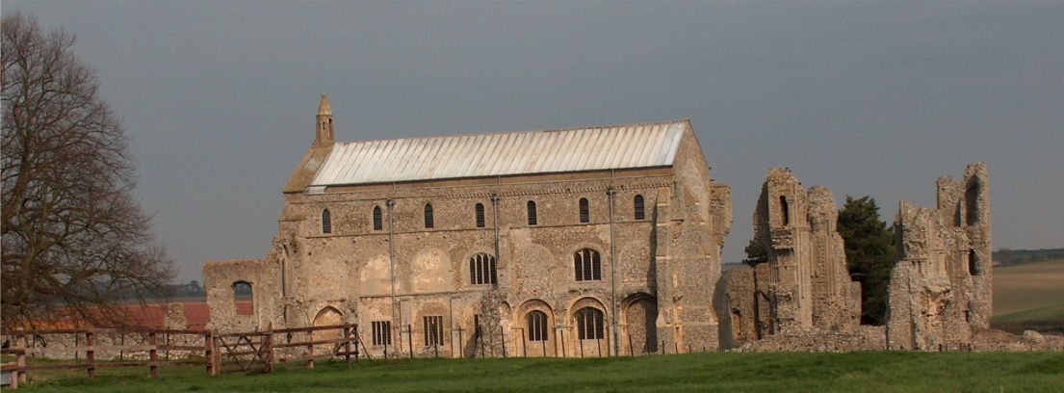
BINHAM PARISH COUNCIL
Locum Parish Clerk – Sarah Hayden
53 Cromer Road, Lower Gresham
NR11 8RH
Tel: 01263 570223
Email: sarah352hayden@btinternet.com

2020/10
MINUTES OF THE PARISH COUNCIL MEETING HELD ON
MONDAY 14th SEPTEMBER 2020 AT THE MEMORIAL HALL

Those Present Cllr. Liz Brady (Chair), Cllr. Liz Brown (Vice Chair), Cllr. P. Alford, Cllr. K. Cooke, Cllr. L. Wynder
In Attendance Mrs. S. Hayden (Locum Clerk), District Cllr. Richard Kershaw (NNDC),
5 Members of the Public

The Chair opened the meeting at 7.32pm.
Covid 19 precautions were in place as per the Parish Council’s Covid 19 Risk Assessment.

1. Apologies received
Apologies were received and accepted from Cllr. H. Owen

2. To receive declarations of interest
None

3. Approval of Minutes of Parish Council Meeting held on 13th July 2020
Approval proposed and resolved, and the Minutes were then signed by the Chairman

4. Matters Arising
The cheque for a donation to McMillan Cancer had not been cashed

5. Reports
5.1 Norfolk County Council
None [Received after meeting and circulated]
5.2 North Norfolk District Council
District Councillor Kershaw reported that all applications for the Discretionary Grant scheme and Business Support grant had been received and would be distributed by the end of September in the total sum of £67m. There would a new grant scheme for businesses to extend the tourism season in N. Norfolk, starting at the end of the month. The tree planting season would commence and the aim was to plant 30,000 trees. Application forms would be on the NNDC website. Cllr. Kershaw advised that the new Community Grant scheme would be suitable for the village Youth Group, who were looking for funds to cover their loss during lockdown. Despite fears, data showed that N. Norfolk business and employment was doing well. NNDC would be acting as a hub for the Government Kickstart scheme, as a firm needed to take 30 young people, which would have precluded smaller businesses.

The Chair expressed the Parish Council’s thanks for dealing efficiently with all the questions raised during the past lockdown months.

5.3 Chair’s Report re: SAMS
The group had been formed before lockdown and they had been able to get data off the machine for three locations - Hindringham Road, Langham Road and Warham Road. The Chair reported on the data, which showed traffic movements on the Warham Road between 20th July and 17th August higher than normal,
2020/11

possibly due to farm traffic. The traffic from Hindringham was on average, faster than the other two roads, although the SAM2 sign was removed after the gates were place, so needs to go back for further data gathering.

The situation of the speed signs, etc was discussed. Hindringham were due to start their Speedwatch training shortly and once operating may help slow the traffic down. Clerk to let the Parish Council know when dates are fixed.

5.4 Chair’s report including any ongoing Covid 19 “Stay Secure” provisions
Newsletters had recently been distributed to the village, including second home owners and these will be continued for the time being. Posters had been done. There were reports of people refusing to wear masks in the shop. There had been a complaint that it was disproportionate to close the play area and the Chair had responded to that. The Committee were entitled to close the area and there was no mandatory law to re-open.

6. Public Questions, comments or representations
A member of the public stated that he didn’t agree with including a public participation item in the Agenda, as he felt is made the meetings would seem unwelcome to the public and they could not comment throughout the meeting as in the past. The Clerk confirmed this item was a trial for this meeting as the Parish Council had to approve Standing Orders later in the Agenda, which contained the relevant clauses. The public were always welcome and this item enabled the public to know when they could speak, the parish councillors could note their comments and take account of them during later discussions. The Chair could allow the public to make a comment at points in the meeting as currently done, although strictly there should be a resolution to allow that to happen. The member of the public explained that the Agenda limited comments to items on the Agenda, which was restrictive. The Clerk explained that the parish councillors could only discuss or make decisions on items on the Agenda, which by law had to be published three days in advance of a meeting, so that the public could attend or make their views known.

7. Planning
7.1 Report from Planning Committee
Cllr. Alford had circulated the report before the meeting. There had been two new applications since July concerning the conversion of the barn at Abbey Farm. Two had been decided since the last meeting and there were two applications outstanding. On the Abbey Farm application for a Café, the planning committee had met with the applicants on site to understand better what was being planned. An ecology survey was now being carried out. The Parish Council were in support of the application. Some parties had raised concerns that conservation and design details were insufficient – these had been revised and submitted. The Council for British Archaeology felt there would have to be a survey as the surface where the car park was proposed was large and had to be dug up to be surfaced. Highways had raised questions, which didn’t seem to tie in with the application.
PF/19/2153 - Pebble Cottage, 87 Warham Road – two storey side and rear extension –awaiting NNDC decision
LA/20/0740 - 1 Front Street - window change in character – awaiting NNDC decision
PF/20/0020 50 Warham Road – variation application for window change – Parish Council had raised traffic issues with deliveries on the sharp bend. The approval had not contained a condition covering traffic management, which was disappointing. The Chair would keep an eye on the traffic situation.
7.2 To discuss and make observations on any applications received after the date of this Agenda
None
7.3 To discuss and agree response to Norfolk Coast Partnership on AONB boundary
Discussed and agreed to ask for an extension of the boundary to include the whole village. Clerk to ask for map including Warham, as the extent of the extension required was not on the map circulated. Chair to map the extension on plans.

2020/12

8. Finance and Regulatory
8.1 To receive Balance Sheet and approve List of Payments
The Balance Sheet was received. It was agreed to add a donation of £25 to the British Legion for the wreath for Remembrance Sunday
8.2 To note Clerk’s salary increase (2.75%) backdated to April 2020
Noted – it was agreed that the increase should be paid to Keith Leesmith as former Clerk who worked from April to June inclusive. The current locum clerk had started on 1st July.
8.3 To consider donation to Youth Group to assist re-opening following Covid shutdown
Agreed that there was £125 in the Budget unspent for donations that could be utilised, plus the balance of the £800 grant, of which £415 was unspent and could also be utilised. Cllr. Kershaw confirmed that the new NNDC Community Fund would be suitable for an application and it was agreed that the Chair would pass their details to the Youth Group. If any funds were needed in the interim, the Parish Council could support them.
As an aside, the bins at the Priory were discussed.
8.4 To approve Standing Orders and Financial Regulations
It was agreed to defer approval until the next meeting to allow more time for the parish councillors to read through them.

9. To receive and discuss any reply from NCC re: footpaths on the Green and consider an application for their addition to the Definitive Map
Cllr. Alford outlined the situation and explained that if we wanted to have the footpaths put on the Definitive Map we would either need to know the landowner or collect statements from local people using the paths over a number of years. Suggested a list could be left in the shop for people to volunteer to make statements. Cllr. Alford to move the paperwork forward.

10. Items for Information Only or Next Agenda
1. Footpath outside Priory needs trimming – Clerk to report to Highways
2. Hedges next to gateways – landowners to be asked if the parish council can maintain
3. Blocked drain at Dairy farm had been reported
4. Signs would be checked for rotting bases before the next meeting
5. Drain near Manor Farm needs unblocking and levelling – Clerk to report
6. Lynx: Cllr. Brady would like to stand down as Editor. Currently there were problems with delivering due to Covid 19. It will be published on line until the end of the year and then there would be limited printed versions for delivery. It was hoped to have a link on the Lynx website, so other sites could publish it.
7. Correspondence: Consultation on Coastal Adaptation Supplementary Planning Document – to be dealt with by Planning Committee
Next Agenda: dog fouling in village, bin in Priory

There being no further business the meeting was closed at 9.20pm and the approved cheques were signed
The next meeting will be on 9th November 2020

