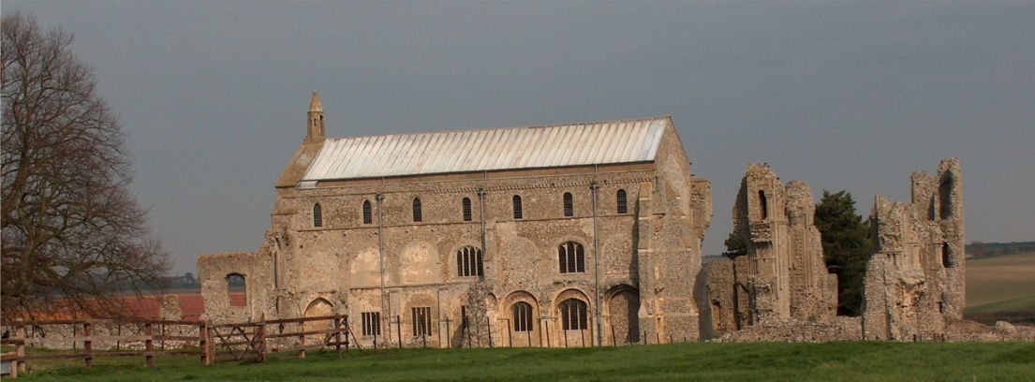
BINHAM PARISH COUNCIL
Locum Parish Clerk – Sarah Hayden
53 Cromer Road, Lower Gresham
NR11 8RH
Tel: 01263 570223
Email: sarah352hayden@btinternet.com

Parish Council Meeting
Members of the Council
You are summoned to attend a meeting of Binham Parish Council at The Memorial Hall on
Monday 14th September 2020 at 7.30pm
S. H. Hayden
Locum Clerk
7th September 2020
The Public are welcome to attend this Parish Council meeting
Covid 19 precautions will be in place
Please bring a mask and use hand sanitiser at door on way in and out
You will be asked to leave your name and telephone number to assist “Track & Trace” – these details to be kept for 21 days and then destroyed

AGENDA
1. To receive and accept apologies for absence
2. To Receive Declarations of Interest
3. Approval of the Minutes of Parish Council Meeting held 13th July 2020
4. Matters Arising

5. Reports
5.1 Norfolk County Council
5.2 North Norfolk District Council
5.3 Chair’s Report re: SAMS
5.4 Chair’s Report including any ongoing Covid 19 “Stay Secure” provisions

6. Public questions, comments or representations
(on matters connected with this Agenda – limited to four minutes per person and twenty minutes in total at discretion of the Chairman)

7. Planning
7.1 Report from Planning Committee
7.2 To discuss and make observations on any applications received after the date of this Agenda
7.3 To discuss and agree response to Norfolk Coast Partnership on AONB boundary

8. Finance and Regulatory
8.1 To receive balance sheet and approve List of Payments
8.2 To note clerk’s salary increase (2.75%) backdated to April 2020
8.3 To consider donation to Youth Group to assist re-opening following Covid shutdown
8.4 To approve Standing Orders and Financial Regulations

9. To receive and discuss any reply from NCC re: footpaths on Green and consider an application for their addition to the Definitive Map
10. Items for Information Only or next Agenda

The next meeting will be on 9th November 2020

