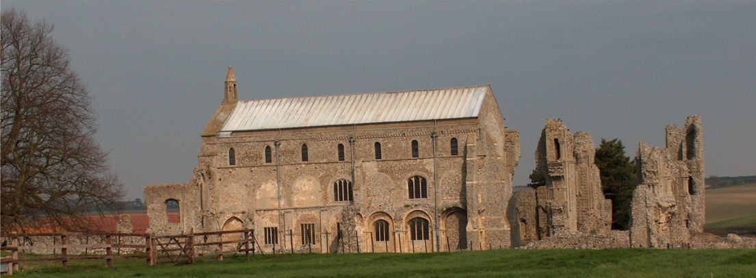
BINHAM PARISH COUNCIL
Parish Clerk – Keith Leesmith
31 Dogger Lane, Wells-next-the-Sea
Norfolk, NR23 1BE 01328 710261
keith@leesmith.co.uk

Parish Council Meeting

The Memorial Hall at 7.30.pm on Monday 16 March 2020

Everyone Welcome! - Tea & Coffee are available at the Memorial Hall from 7.00pm

AGENDA
1) Apologies

2) To Receive Declarations of Interest

3) Approval of the Minutes of Parish Council Meeting held 20 January 2020

4) Reports:
- Norfolk County Council
- North Norfolk District Council
- Parish Clerk
- Liaison Meetings of the Priory Close/Walsingham Rd development
- SAM2 updates

5) Any Planning Matters to hand

6) To discuss the possibility of installing public electric car charger(s) [PA]

7) To consider financial appeals from The Lynx and others

8) Financial Report & Accounts for Settlement

9) Minor Items

10) To confirm the date of the Next Meeting – Monday 11 May 2020

11) To consider a resolution under the Public Bodies (Administration of meetings Act) 1960, as amended by Section 100 of the Local Government Act 1972 to exclude members of the public and press during consideration of an item regarding a confidential matter.

12) To discuss the co-option of two additional Parish Councillors

