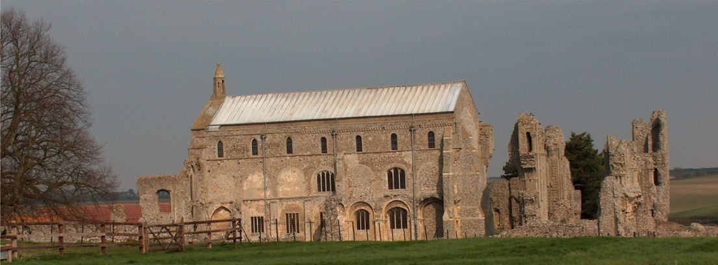
BINHAM PARISH COUNCIL
Parish Clerk – Keith Leesmith
31 Dogger Lane, Wells-next-the-Sea
Norfolk, NR23 1BE 01328 710261
keith@leesmith.co.uk

Parish Council Meeting

The Memorial Hall at 7.30.pm on Monday 20 January 2020

Everyone Welcome! - Tea & Coffee are available at the Memorial Hall from 7.00pm

AGENDA
1) Apologies

2) To Receive Declarations of Interest

3) Approval of the Minutes of Parish Council Meeting held 18 November 2019

4) Reports:
- Norfolk County Council
- North Norfolk District Council
- Parish Clerk
- Liaison Meetings of the Priory Close/Walsingham Rd development
- Any SAM2 updates
- Report from Police meeting – 21 November

5) Any Planning Matters to hand

6) To discuss the appointment of a new Parish Clerk

7) To discuss the vacancy for a Parish Councillor

8) Financial Report & Accounts for Settlement

9) Minor Items

10) To confirm the date of the Next Meeting – Monday 16 March 2020

