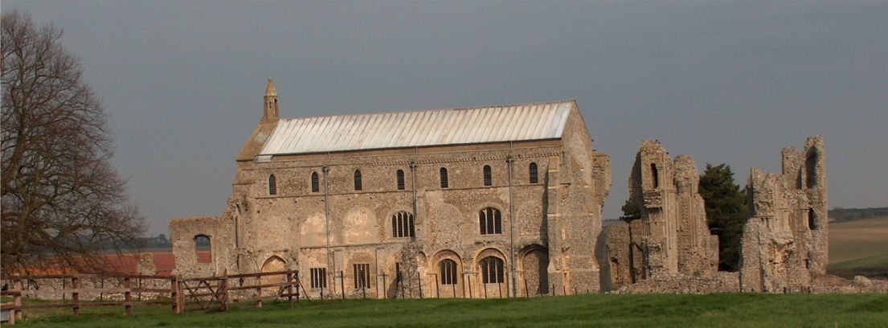
BINHAM PARISH COUNCIL
Locum Parish Clerk – Sarah Hayden
53 Cromer Road, Lower Gresham
NR11 8RH
Tel: 01263 570223
Email: sarah352hayden@btinternet.com

Parish Council Meeting
Members of the Council
You are summoned to attend a meeting of Binham Parish Council at The Memorial Hall on
Monday 13th July 2020 at 7.30pm
S. H. Hayden
Locum Clerk
6th July 2020

The Public are welcome to attend this Parish Council meeting

Covid 19 precautions will be in place
Please use hand sanitiser at door on way in and out
You will be asked to leave your name and telephone number to assist “Track & Trace” – these details to be kept for 21 days and then destroyed

AGENDA
1. Apologies

2. Signing of Acceptance of Office by Co-Opted Parish Councillors

3. To Receive Declarations of Interest

4. Approval of the Minutes of Parish Council Meeting held 18th May 2020

5. Matters Arising

6. Reports
5.1 Norfolk County Council
5.2 North Norfolk District Council
5.3 Liaison Meetings of the Priory Close/Walsingham Rd development
5.4 Chair’s Report on Grant funds and any ongoing Covid 19 “Stay Secure” provisions

7. Planning
7.1 Report from Planning Committee
7.2 To discuss and make observations on any applications received after the date of this Agenda

8. Financial Report & Accounts for Settlement

9. To approve Parish Council Covid 19 Risk Assessment

10. To discuss the possibility of installing public electric car charger(s) [PA]

11. Items for Information Only or next Agenda

The next meeting will be on 14th September 2020

